

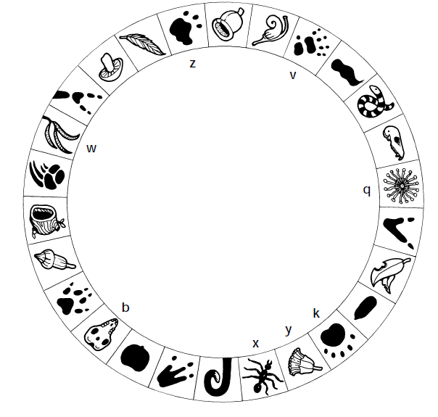

**Toolibin Lake Catchment**

**Year 9- October 2021**

1. What makes Toolibin Lake important?

______________________________________________________________________________________________________________________________________________________________________________________________________________________________________________________________________________________________________________________________________________________________________________________________________________________

**Bird Life**

1. How many bird species have been recorded in the lake?

_____________

1. How many waterbirds are there in Toolibin Lake?

____________________

1. Name 4 waterbirds that use Toolibin Lake.

________________________________

________________________________

________________________________

________________________________

1. Which catchment is Toolibin Lake located in?

____________________________________________________________________________________________________________________

1. What is the area of Toolibin Lake?

__________________________

1. What is the annual rainfall at Toolibin Lake?

___________________________

1. Whilst you are walking out on to the bund look to your right and then look to your left (Toolibin Lake floor). Describe the differences in vegetation you can see.

|  |  |
| --- | --- |
| Left (Toolibin Lake floor) | Right |
|  |  |
|  |  |
|  |  |
|  |  |
|  |  |
|  |  |
|  |  |

1. What do you think may have caused these differences?

____________________________________________________________________________________________________________________________________________________________________________________________________________________________________________________________________________________________________________________________________________________________

1. List at least four main threats to Lake Toolibin.

____________________________________________

____________________________________________

____________________________________________

____________________________________________

____________________________________________

1. Where does the salt come from?

____________________________________________________________________________________________________________________

**Major Recovery Actions**

1. Why is there a separator gate/diversion structure installed at Toolibin Lake

____________________________________________________________________________________________________________________________________________________________________________________________________________________________________________________________________________________________________________________________________________________________

1. When was the diversion structure built?

___________________________

1. How does the diversion structure work?

____________________________________________________________________________________________________________________________________________________________________________________________________________________________________________________________________________________________________________________________________________________________

1. Where does the saline water get diverted to?

____________________________________________________________________________________________________________________________________________________________________________________________________________________________________________________________________________________________________________________________________________________________

1. What other methods are used to protect Toolibin Lake? ____________________________________________________________________________________________________________________________________________________________________________________________________________________________________________________________________________________________________________________________________________________________
2. How much ground water is pumped out every day?

____________________________________________________________________________________________________________________

Monitoring the health of Toolibin Lake

1. Complete the following table

|  |  |
| --- | --- |
| Distance from pump(m) | Ground water depth below ground level (m) |
|  |  |
|  |  |
|  |  |
|  |  |
|  |  |

1. What important information does this monitoring site provide?
2. Have there been any major setbacks/challenges in the quest to protect this unique community?
3. What role do local land owners play in helping to conserve Lake Toolibin?

__________________________________________________________________________________________________________________________________________________________________________________________________________________________________________________________________________________________________

1. What does your job entail at Lake Toolibin?

________________________________________________________________________________________________________________________________________________________________________________________________________________________________________

1. What qualifications did you need to get this job?

____________________________________________________________________________________________________________________

1. What is the most exciting thing that you have observed in your time so far at Lake Toolibin?

__________________________________________________________________________________________________________________________________________________________________________________________________________________________________________________________________________________________________

1. How would the traditional owners of the Land (Noongar- Wilman)

people have used this area.

____________________________________________________________________________________________________________________